DATAWARE HOUSING AND DATA MINING

ASSIGNMENT 3

GROUP MEMBERS

MUHAMMAD BILAL AHMED (FA20-BCS-041)

MUHAMMAD SALMAN (SP20-BCS-131)

1. **Datawarehouse creation**

We created Datawarehouse in SQL server using SQL Queries.

Datawarehouse consist of

1. **Dimensions**

Dimensions are individual, non-overlapping elements. The dimensions facilitate the filtering, grouping, and labelling of the data. Dimension tables have textual descriptions about the business subjects. In our case Dimensions were Customer, Employees, Time, Products.

1. **Fact Table**

The data stored in a Fact Table is known as Measures (also dependent attributes). The fact table should give statistics of sales broken down by customer, product, period, Employees. Fact table contains following attributes

* **Foreign keys:**

Customer id, Employee id, Order line id, Product id

* **Measure:**

Total purchase amount, Total sale amount, profit

We use star schema for dimension modeling.

**Star schema:**

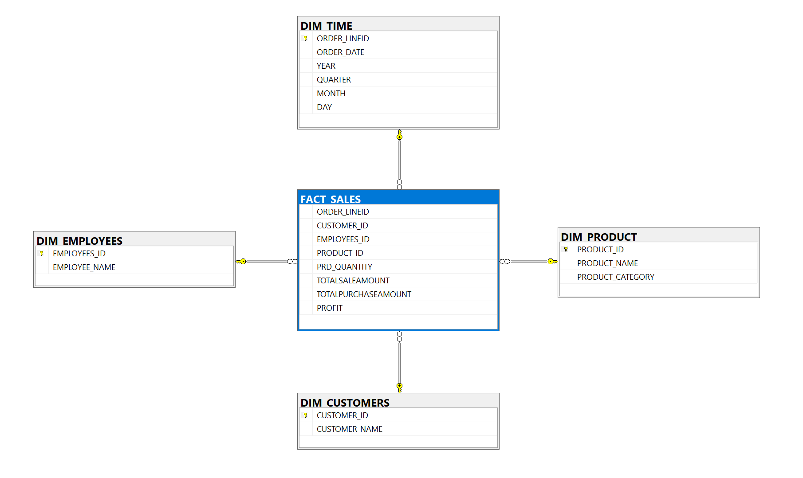

1. **Creating Dimensions and inserting data using SQL SERVER**

**Product Dimension**

CREATE TABLE DIM_PRODUCT

(

PRODUCT_ID INT NOT NULL PRIMARY KEY,

PRODUCT_NAME VARCHAR(50) NOT NULL,

PRODUCT_CATEGORY VARCHAR(50) NOT NULL,

SALE_PRICE INT NOT NULL,

);

**Inserting data into Product Dimension**

INSERT INTO DIM_PRODUCT(PRODUCT_ID, PRODUCT_NAME, PRODUCT_CATEGORY, SALE_PRICE)

SELECT DISTINCT (PRODUCTS.PRODUCT_ID),

PRODUCTS.PRODUCT_NAME, PRODUCT_CATEGORY.CATEGORY_NAME, [DWDM_PROJECT].[DBO].ORDER_LINE.PRICE_EACH

FROM [DWDM_PROJECT].[DBO].PRODUCTS

JOIN [DWDM_PROJECT].[DBO].PRODUCT_CATEGORY

ON PRODUCTS.PRD_CATEGORY_ID = PRODUCT_CATEGORY.PRD_CATEGORY_ID

JOIN [DWDM_PROJECT].[DBO].ORDER_LINE

ON PRODUCTS.PRODUCT_ID = [DWDM_PROJECT].[DBO].ORDER_LINE.PRODUCT_ID

ORDER BY PRODUCTS.PRODUCT_ID ASC;

**Customer dimension**

CREATE TABLE DIM_CUSTOMERS

(

CUSTOMER_ID INT NOT NULL PRIMARY KEY,

CUSTOMER_NAME VARCHAR(50),

);

**Inserting data in Customer dimension**

INSERT INTO DIM_CUSTOMERS(CUSTOMER_ID, CUSTOMER_NAME)

SELECT CUSTOMERS_ID,CUSTOMER_NAME FROM [DWDM_PROJECT].[DBO].CUSTOMERS

**Time Dimension**

CREATE TABLE DIM_TIME

(

ORDER_LINEID INT NOT NULL PRIMARY KEY,

ORDER_DATE DATE,

YEAR INT,

QUARTER INT,

MONTH INT,

DAY INT,

);

**Inserting data into Time Dimension**

INSERT INTO DIM_TIME(ORDER_LINEID, ORDER_DATE, YEAR, QUARTER, MONTH, DAY)

SELECT [DWDM_PROJECT].[DBO].ORDER_LINE.ORDERLINE_ID, [DWDM_PROJECT].[DBO].ORDERS.ORDER_DATE,

YEAR([DWDM_PROJECT].[DBO].ORDERS.ORDER_DATE) AS Year,

DATEPART(qq, [DWDM_PROJECT].[DBO].ORDERS.ORDER_DATE) AS QUARTER,

MONTH([DWDM_PROJECT].[DBO].ORDERS.ORDER_DATE) AS MONTH,

DATEPART(dd, [DWDM_PROJECT].[DBO].ORDERS.ORDER_DATE) AS DAY

FROM [DWDM_PROJECT].[DBO].ORDER_LINE

JOIN [DWDM_PROJECT].[DBO].ORDERS ON

[DWDM_PROJECT].[DBO].ORDER_LINE.ORDER_ID = [DWDM_PROJECT].[DBO].ORDERS.ORDER_ID

**Employee Dimension**

CREATE TABLE DIM_EMPLOYEES

(

EMPLOYEES_ID INT NOT NULL PRIMARY KEY,

EMPLOYEE_NAME VARCHAR(100),

)

**Inserting data Employee Dimension**

INSERT INTO DIM_EMPLOYEES(EMPLOYEES_ID, EMPLOYEE_NAME)

SELECT EMPLOYEES_ID,EMPLOYEE_NAME FROM [DWDM_PROJECT].[DBO].EMPLOYEES

**Fact_Sales**

CREATE TABLE FACT_SALES

(

ORDER_LINEID INT FOREIGN KEY REFERENCES DIM_TIME(ORDER_LINEID),

CUSTOMER_ID INT FOREIGN KEY REFERENCES DIM_CUSTOMERS(CUSTOMER_ID),

EMPLOYEES_ID INT FOREIGN KEY REFERENCES DIM_EMPLOYEES(EMPLOYEES_ID),

PRODUCT_ID INT FOREIGN KEY REFERENCES DIM_PRODUCT(PRODUCT_ID),

PRD_QUANTITY INT,

TOTALSALEAMOUNT INT NOT NULL,

TOTALPURCHASEAMOUNT INT NOT NULL,

PROFIT INT

);

**Inserting data into Fact table**

SELECT DISTINCT [DWDM_PROJECT].[DBO].ORDER_LINE.ORDERLINE_ID,[DWDM_PROJECT].[DBO].ORDERS.CUSTOMERS_ID,[DWDM_PROJECT].[DBO].ORDERS.EMPLOYEES_ID,

[DWDM_PROJECT].[DBO].ORDER_LINE.PRODUCT_ID,

[DWDM_PROJECT].[DBO].ORDER_LINE.PRD_QUANTITY,

[DWDM_PROJECT].[DBO].ORDER_LINE.PRICE_EACH * [DWDM_PROJECT].[DBO].ORDER_LINE.PRD_QUANTITY AS [TOTAL SALE AAMOUNT],

[DWDM_PROJECT].[DBO].PURCHASE_DETAILS.PURCHASE_PRICE * [DWDM_PROJECT].[DBO].ORDER_LINE.PRD_QUANTITY AS [TOTAL PURCHASE AMOUNT],

(([DWDM_PROJECT].[DBO].ORDER_LINE.PRICE_EACH - [DWDM_PROJECT].[DBO].PURCHASE_DETAILS.PURCHASE_PRICE) * [DWDM_PROJECT].[DBO].ORDER_LINE.PRD_QUANTITY) AS [TOTAL PROFIT]

FROM [DWDM_PROJECT].[DBO].ORDER_LINE

INNER JOIN [DWDM_PROJECT].[DBO].ORDERS

ON [DWDM_PROJECT].[DBO].ORDER_LINE.ORDER_ID = [DWDM_PROJECT].[DBO].ORDERS.ORDER_ID

INNER JOIN [DWDM_PROJECT].[DBO].PURCHASE_DETAILS

ON [DWDM_PROJECT].[DBO].ORDER_LINE.PRODUCT_ID = [DWDM_PROJECT].[DBO].PURCHASE_DETAILS.PRODUCT_ID

ORDER BY ORDERLINE_ID ASC;